A Sample Document

Author’s Name
Author’s Affiliation and E-mail Address

Abstract: This is a sample input file. Comparing it with the output it generates can show you how to produce a simple document of your own.

Keywords: sample, Word

Ordinary Text

All ordinary text is in Times New Roman, 11-point type (style “Normal”). The ends of words and sentences are marked by a single space
One or more blank lines denote the end of a paragraph. With the exception of the first paragraph, subsequent paragraphs in each section are indented .25”.
Dashes come in three sizes: an intra-word dash, a medium dash for number ranges like 1–2, (en dash) and a punctuation dash— like this (em dash).
Text that needs special emphasis should be in an italic type style. A long segment of text can also be emphasized in this way. Text within such a segment may be given additional emphasis with Roman type. Italic type loses its ability to emphasize and become simply distracting when used excessively.
It is sometimes necessary to prevent text from breaking a line where it might otherwise do so.
This may be at a space, as between the “Mr.” and “Jones” in “Mr. Jones”, or within a word

Notes

Footnotes may be included. Endnotes may be included as well.

Organizational Text

In addition to the “normal” type style, you may use “quotation” style when appropriate. There
are short quotations:
This is a short quotation. It consists of a single paragraph of text. The entire paragraph is indented.
and longer ones.
This is a longer quotation. It consists of two paragraphs of text. The beginning of each
paragraph is indicated by an extra indentation.
This is the second paragraph of the quotation. It is just as dull as the first paragraph.
Another frequently-displayed structure is a list. The following is an example of an itemized list.

- This is the first item of an itemized list. Each item in the list is marked with a bullet. The document style determines which bullet is used.

- This is the second item of the list. It contains another list nested inside it.

  - This is the first item of an enumerated list that is nested within the itemized list.
  - This is the second item of the inner list. Word allows you to nest lists deeper than you really should.

This is the rest of the second item of the outer list. It is no more interesting than any other part of the item.

- This is the third item of the list.

The following is an example of an enumerated list.

- This is the first item of an enumerated list. Each item in the list is marked with a number.

- This is the second item of the list. It contains another list nested inside it.

- This is the first item of an enumerated list that is nested within the enumerated list.
- This is the second item of the inner list.

This is the rest of the second item of the outer list. It is no more interesting than any other
part of the item.

- This is the third item of the list.

Headings

4.1. Subsection

The text for the subsection is inserted here, in the “normal” formatting.

4.1.1. Subsubsection
The text for the subsubsection is inserted here. (Carr and Goldstein, 1977; Cohen and Jones, 1989) based their model on balancing methods and biochemical knowledge. The original model (1980) contained an equation for the oxygen dynamics which has been omitted in a second paper (1981). This simplified model shall be discussed here.

4.1.1.1. Paragraph. The text for the paragraph section is inserted here. (Carr and Goldstein, 1977; Cohen and Jones, 1989) based their model on balancing methods and biochemical knowledge. The original model (1980) contained an equation for the oxygen dynamics which has been omitted in a second paper (1981). This simplified model shall be discussed here.

Subparagraph. The text for the subparagraph is inserted here. (Carr and Goldstein, 1977; Cohen and Jones, 1989) based their model on balancing methods and biochemical knowledge.

Figures and Captions

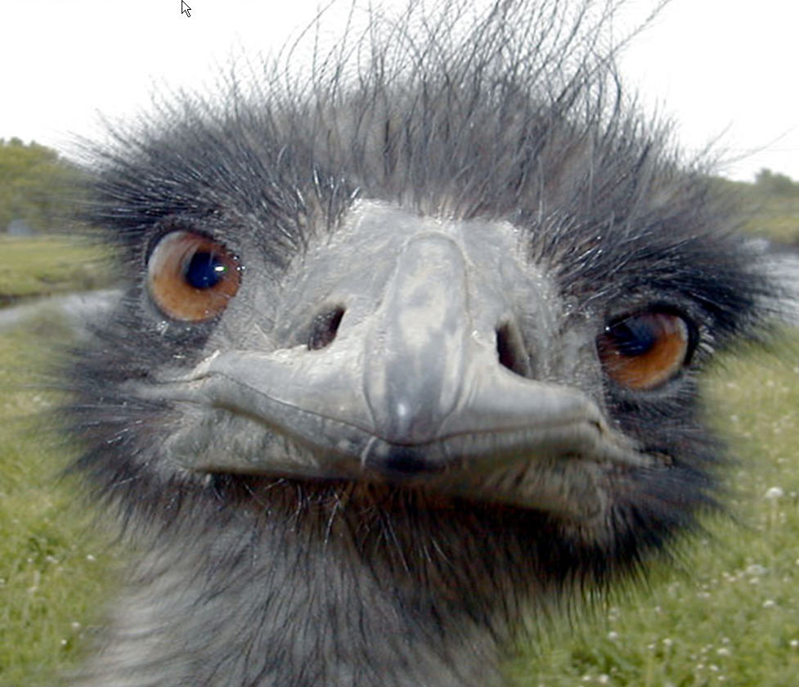

Figure 1. Titles and captions should be centered.

Text after captions should continue in the “normal” mode.
In the model van (1990), at severe substrate limitation conditions, and thus most probably corresponding to endogenous metabolic behaviour, the biomass consumption due to maintenance and production requirements may exceed the conversion of substrate into biomass and may eventually may become negative.

Acknowledgements

Thanks to everyone for all of their help.

End Notes

An example of a footnote.
An example of an endnote. References Brown, J. S. and R. R. Burton. Diagnostic Models for Procedural Bugs in Basic Mathematical Skills. Cognitive Science, 2(2):155{192, 1978. Buchanan, B. G. and E. H. Shortliffe. Rule-Based Expert Systems: The MYCIN Experiments of the Stanford Heuristic Programming Project. Addison-Wesley Publishing Company, 1984. Bunt, H. C. Modular Incremental Modelling of Belief and Intention. In Proceedings of the Second International Workshop on User Modeling, 1990.

